AUGMENTED REALITY

CONTENT

1. Brief

2. Development

3. AR Devices

4. AR Products

5. Market of AR

6. India Augmented Reality and Virtual Reality Market Set to Grow at CAGR 55%

till 2021

7. Scope of AR in India

8. Types of Augmented Reality Apps that can

solve various problems in India

9. Future of AR

BRIEF

4IR technologies cut across digital, physical and biological domains are as follows:-

1. Think artificial intelligence (AI)

2. The internet of things (IoT)

3. Self-driving vehicles

4. Augmented and virtual reality (AR and VR) and bio-tech including gene editing tools, or nanotechnology.

Augmented reality is the interaction of superimposed data, graphics, audio and other sensory enhancements over a real-world environment that is displayed in real time – the world we actually see, the world within which we actually work, the world our citizens navigate every day. (AR should not be confused with virtual reality, which places the user in a created, virtual, world.) Global technology leaders, including Google, Microsoft, Facebook, Snapchat and Apple, have all staked significant claims in the AR “digital” land rush. The devices that will deliver the augmented reality experiences, have finally begun to mature.

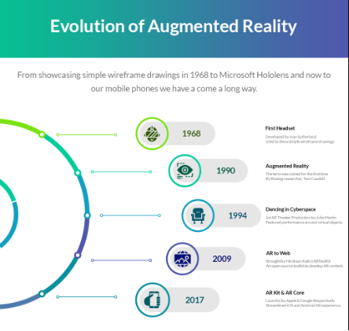

DEVELOPMENT

A range of major products came to market in 2016 from companies including Oculus VR, Sony and Google. Since it bought Oculus for $2.1 billion, Facebook has acquired a further 11 AR/VR companies, underscoring the company’s view that VR and AR will form the next frontier.

AR DEVICES

Over the past few years, the core AR software and most important the devices that will deliver the augmented reality experiences, have finally begun to mature. They include:

1. Handhelds and mobile devices, primarily smartphones and tablets, and built-for-purpose mobile workforce devices

2. Head-up displays (HUDs) for windshields, screens, visors

3. Head mounted displays (HMDs)

4. Glasses, goggles, visors and helmets

5. Contact lenses, virtual retina displays

6. Spatial displays

PRODUCTS

**Penrose Studios**

THE STUNNING ALLUMETTE IS THE FIRST VR FILM MASTERPIECE”. CREATORS OF VIRTUAL REALITY WORLDS & STORIES.

PENROSE STUDIOS is at the forefront of virtual reality as a storytelling medium. It’s an opportunity for audiences to make an emotional connection through VR as a storytelling medium.

PENROSE STUDIOS, the technology startup known for its advancements in VR storytelling, today announced it raised an $8.5 million seed round.This represents the augmented reality (AR) and virtual reality (VR) industry's largest institutional seed round.

**Meta company**

1. Meta 1 Developer Kit (Kickstarter 2013-05-17) :- Meta 1 shows you virtual 3D objects that are mixed in with the real world in front of you. The 3D Camera Tracks Hand Movements. Resolution that goes down to an individual fingertips is supported. “Thumbs up” movement a “Like” post on Facebook can be recognized. It also has integrated WiFi and runs Android.

2. Meta 2 Development Kit (pre-orders 2016-03-02) :-The Meta 2 boasts a huge 90-degree field of view. It’s also a full-fledged 1,440p screen, thanks to a mirrored overhead display. The sensor array in the Meta 2 handles hand and location tracking for the headset, allowing for a completely hand-controlled experience. It also means no stationary tracking fixtures, like the HTC Vive’s lighthouse.

3. Meta Pro (prototype) :-As the company has an SDK which allows developers to create programs to use with the glasses. The glasses can be used in place of traditional CAD software to design a 3D printed object using only your hands. This prototype gives a good idea of the core technology and capabilities. Previously only been seen in movies such as Iron Man. The system tracks hands without the need for gloves, identifying yours and others, so multiple people can interact in the same AR world at the same time.

**Augmedix**

Doctors are wearing the new Google Glass while seeing patients. Enables physicians to wear Glass Enterprise Edition as they see patients, while remote medical scribes fill out the electronic medical records based on what they hear and see from the visit. Put on Glass, go have normal conversations with your patients." Meanwhile, the audio and video streamed from the Glass go to a trained medical scribe, who may be located in a place like California, India, or Bangladesh, and whose job it is to fill in the electronic health records.

The integrated display on Glass can be used to provide the doctor with information about the patient in real time as they perform the examination.

Augmedix first started using Explorer-edition models (that’s what it was called when it was marketed to consumers) of the device in 2013, Shakil says.Today, all their physicians are using the new Enterprise version.

**HaoLi (Pinscreen)**

Working at visual effects studio Industrial Light & Magic, Li helped develop some tools that enabled real-time performance capture. The idea was that an actor could sit in front a computer with a web camera, act out a scene, and then that performance would be translated — in real-time — to a CG character. The crafting of 3D models of real people in real-time, and capturing important parts of their likeness, especially faces and hair. Most recently, Li showed off research that he and others had conducted in capturing a performance from a person with just a single camera,and translating that to a digital character.

Pinscreen “built a deep convolutional neural network that can learn how to segment a face region in a fully unconstrained image.”

MARKET OF AR

A range of major products came to market in 2016 from companies including Oculus VR, Sony and Google. Since it bought Oculus for $2.1 billion, Facebook has acquired a further 11 AR/VR companies, underscoring the company’s view that VR and AR will form the next frontier. According to a recent estimate by Goldman Sachs, AR and VR are expected to grow into a $95 billion market by 2025. As the chart below shows, the strongest demand for the technologies currently comes from industries in the creative economy - specifically, gaming, live events, video entertainment and retail – but will find wider applications in industries as diverse as healthcare, education, the military and real estate over time. 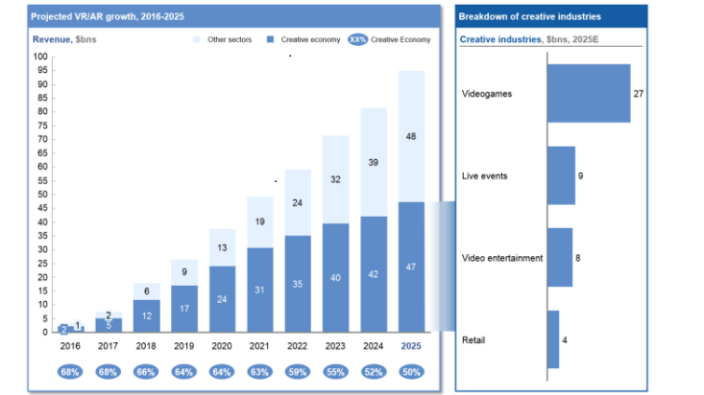

India Augmented Reality and Virtual Reality Market Set to Grow at CAGR 55% till 2021

* Increasing adoption of head-mounted display in gaming industry and defense aircraft to drive India augmented reality and virtual reality market through 2021.

* Augmented reality (AR) and virtual reality (VR)market in India is projected to register a CAGR of 55.3% during 2016 - 2021. Rising adoption of AR & VR based products such as head-up display, head-mounted display, etc., among various end users including defense, automotive, consumer electronics, etc., is anticipated to drive the growth in the country’s AR & VR market over the next five years.

In 2015, gaming market in India was over US$ 501 million and it is forecast to cross US$ 792 million in value terms by 2021.

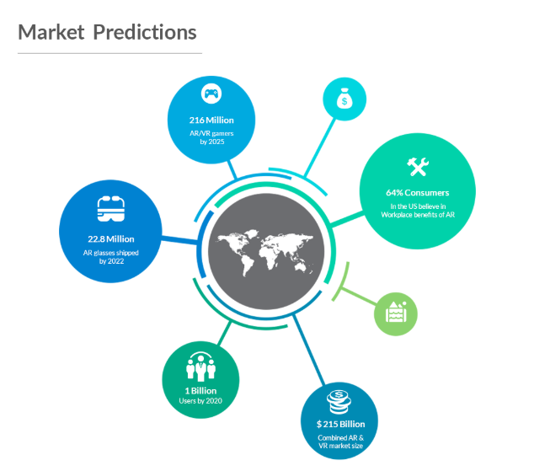

Scope OF AR IN INDIA

1. **Retail marketing:** Both in-store and [online marketing](https://www.orangemantra.com/services/online-marketing-services/) are being revolutionized by AR applications. Concepts like AR-assisted window shopping, virtual try rooms, interactive kiosks, and immersive product catalog visualization are already making it big in this industry.

Best Examples:

**Lenskart:-** Lenskart launches online trial room feature to enhance customer experience.  [Lenskart](http://www.lenskart.com/) has introduced a [virtual trial room feature](http://retail.economictimes.indiatimes.com/news/e-commerce/e-tailing/ecommerce-firms-like-lenskart-turn-to-virtual-trial-technology-to-woo-customers-and-beat-competition/49446825), where its potential buyers can try on the spectacles before they purchase them. Buyers can click a selfie through their webcam , and pick out glasses that best suit their face through a 3D feature.

**Trialkart:-** Trialkart is virtual trial and deep learning company providing various proprietary technology solutions and experiences to its customers.

**2. Education and training:** AR applications are serving as the backbone of simulative training. From field trips to interactive walkthroughs, tutorials, and guest lectures, the technology is making them all possible.

Best Examples:

**Yeppar:-** When a document linked with YeppAR is viewed through the YeppAR smartphone app, it comes alive on the smartphone. This can be through 3D visuals, more images, videos, and more details about the content of the document. In this digital age where digital content is pushing print media down, Augmented Reality technologies like YeppAR can give print media a new lease of life. It can also prove helpful for advertisers as they can include a lot more information within the limited space of newspapers, brochures, catalogs etc.

**Ingage:-** InGage is India’s leading digital customer engagement company specializing in a patented technology that blends Augmented Reality, Virtual Reality, Mixed Reality and Immersive Digital Experience to engage audiences and build brands. We provide mobility solutions that seamlessly integrate with your brand to provide an amazing customer experience.Augmented Reality in education is a revolutionary concept that makes virtual objects like atom/molecules , planets , volcanoes , the human heart or dinosaurs come alive and highly interactive on the pages of a book , interactive white board or even on the floor or wall to provide a 3D animated replica that fills the room.



*AR and VR in the classroom have tech startups and textbook publishers excited*

**3. Healthcare:** AR spells phenomenal growth for the healthcare industry too. Surgeons can now polish their skills with simulative surgeries. Equipment simulation, phobia treatment, and physical therapy training are some other areas where this technology is expected to work.

Best Examples:

## **Telementoring :-** This application of AR vastly expands the range and expertise of the physician working on a complex procedure. Suppose if a given operation requires deeply expert ands of a specialist but he/ she is not available on the hospital premises (or may be present in an altogether different geography), AR can come in handy.

With AR, a medical professional can become actively involved in an on-going procedure. This is achieved by virtually superimposing his/ her hand using Google Glasses for showing the right way to do a detailed task during the operation.

**Vision aid :-** Most of the legally blind people have a little bit of vision left in them. However this is not sufficient to do daily tasks like recognizing faces or reading or evading obstacles in their path. The startup VA-ST helps them to recreate some sense of vision using Augmented Reality. This will create a rough outline of a face (somewhat like a stenciled sketch). This will enhance the level of vision available to the user in poorly lit areas and those with lower level of visibility can figure out an object or a person in front him or her, to a better degree.

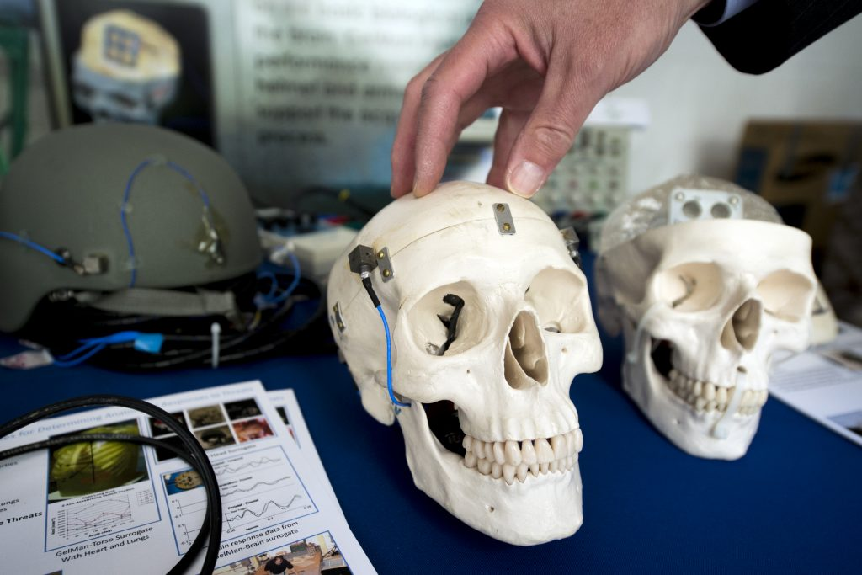

**4. Manufacturing industry:** Augmented Reality will also drive the manufacturing processes in the coming time. With advanced concepts like computer-aided design, computer-aided manufacturing, and product simulation, the industry will experience drastic changes.

Other verticals like real estate, travel and hospitality, aviation, etc will also come across some innovative benefits by embracing this technology. The key is to a capable and reliable technology partner to help make this adoption a seamless one. At OrangeMantra, we are a trusted technology partner that caters expert [AR and VR services](https://www.orangemantra.com/services/ar-vr-application-solution/) for businesses that want to tread this futuristic path.

Types of Augmented Reality Apps that can solve various problems in India

**Location-based AR apps :-** Ingress, Pokemon GO, Wikitude and many more fall into this category. This type unites 3 parametres - your GPS location, compass and accelerometer in order to give you the accurate data on what you see on the screen.

**Projection based apps :-** Amikasa and IKEA Catalog could be divided into this group. This type, as it seems obvious from its name, “projects” objects or images in digital space. It helps you to visualize if a costy sofa you are willing to buy is a good fit in terms of in-house capacity and atmosphere.

**Face-recognition AR apps :-** Make Up Genius by L'oreal and freshly-launched Sephora Visual Artist (back in the time this article was written) are based on face-recognition technology. The basic principle it stands on, is well-described by iGreet company - “the AR app detects and recognizes something called AR marker.

Once it recognizes the marker, it replaces it with a corresponding object.” In the case of previously mentioned apps, your face, each and every part of it is a “marker” app uses to apply various ready-to-wear make up combinations.

A Real Life Example

Augmented Reality Imaging System: 3D Viewing of a Breast Cancer

To display images of breast cancer from a dedicated breast CT using Depth 3-Dimensional (D3D) augmented reality.

**Conclusion**

The augmented reality system provided 3D visualization of the breast cancer with depth perception and visualization of the mass's spiculations. The augmented reality system should be further researched to determine the utility in clinical practice.

Future Of AR

The Future Application extends to infinite possibilities for distinct industries.

But there are 3 use cases that will definitely stand out.

